# Science Under Selection: ODD Model Description for Preregistration

## 1. Purpose

The purpose of this model is to investigate how different academic incentive structures influence the balance between original and replication research, and in turn, the quality of scientific progress. Taking an evolutionary approach, the model simulates how researchers’ tendencies for original or replication research evolve within an academic ecosystem under varying selection pressures. Specifically, the model will be used to (1) examine the effects of novelty-based selection, aiming to independently replicate aspects of the dynamics described in The Natural Selection of Bad Science (Smaldino & McElreath, 2016); (2) explore truth-based selection, a utopian condition, to reveal the optimal dynamics of original and replication research; and (3) explore a corrective condition, which begins with novelty-based selection then switches to truth-based selection, to identify possible pathways toward more reliable and sustainable scientific progress from our current position.

### *Preregistration*

This document uses the ODD (Overview, Design concepts, and Details; Grimm et al., 2020) protocol as a preregistration template for an agent-based model (ABM). While ODD is conventionally applied to describe models after they have been implemented, there is currently no established protocol for preregistering ABMs. We therefore adapt ODD for this purpose, treating it as a structured way to specify the model’s intended design prior to developing the model. This preregistration serves as the initial reference point for transparency, and any adjustments that become necessary while building the model will be documented explicitly. With this first attempt in preregistering an ABM, we hope to make progress in understanding whether and how preregistration can be useful for ABMs.

We consider this research exploratory and thus do not make any explicit hypotheses. At the time of preregistration, we have begun coding the structure of the model, but have not implemented key mechanisms. For example, studies are not distinguished as original or replication, study outcomes are dummy values, and there are no career turnover mechanisms. As such, the model is not in a state where meaningful outcomes could be observed. For transparency, we include a snapshot of the current code alongside this preregistration to document the development stage at which it was written.

## 2. Entities, state variables, and scales

***Entities.*** Researchers (see Table 1) are the primary agents. They differ in their tendency to produce original vs. replication research and are subject to evolutionary pressures through promotion (i.e., they continue in academia or exit the system). Studies (see Table 2) are the outputs of researcher activity, which can be unpublished or published. In our model, all studies are single-author studies. They are characterised in terms of their type (original or replication) and their influence on the belief distribution about an effect. Effects (see Table 3) represent phenomena under study. Each effect has a ground-truth distribution and a community belief distribution, which is updated when studies are published.

***Scales.*** Time in the model is represented in discrete steps, with one timestep corresponding to a fixed time interval (e.g., one month). Career turnover is evaluated at regular intervals after a set number of timesteps. Simulations will be run for a number of timesteps sufficient to observe equilibrium between original and replication work. The model does not include any spatial dimensions.

**Table 1**

*Researcher entities and their state variables*

| **State Variable** | **Description** | **Units** | **Variability** | **Range/Values** |
| --- | --- | --- | --- | --- |
| Researcher ID | Unique identifier for each researcher | – | Static | Positive integers |
| Timestep | Timestep when recording researcher information | Timesteps | Static | Positive integers |
| Replication probability | Probability of producing a replication study (vs. original) | Probability | Static | [0,1] |
| Target power | Target statistical power an agent uses to determine sample size; probability of correctly detecting a true effect | Probability | Static | [0,1] |
| Career status | Whether the researcher is active or has exited academia | – | Dynamic | 0 = inactive, 1 = active |

**Table 2**

*Study entities and their state variables*

| **State Variable** | **Description** | **Units** | **Variability** | **Range/Values** |
| --- | --- | --- | --- | --- |
| Study ID | Unique identifier for each study | – | Static | Positive integers |
| Researcher ID | Unique identifier of the researcher who authored the study (we assume only single-author studies) | – | Static | Positive integers |
| Effect ID | Unique identifier of the effect the study investigates | – | Static | Positive integers |
| Timestep completed | Timestep when study is completed | Timesteps | Static | Positive integers |
| Sample size | Number of data points collected | Observations | Static | Positive integers |
| Estimated mean | The population effect size of Effect ID based on this study | Cohens d | Static | [-∞, ∞] |
| Estimated standard error | The standard error of Estimated mean based on this study | Cohens d | Static | [0, ∞] |
| *p*-value | Probability of observing the result under the null hypothesis | Probability | Static | [0,1] |
| Novelty contribution | How much the study shifted the community belief distribution (regardless of truth) | – | Static | [0, ∞] |
| Truth contribution | How much the study shifted the community belief distribution toward the truth | – | Static | [-∞, ∞] |
| Publication status | Whether the study is published or not | – | Dynamic | 0 = not published, 1 = published |

**Table 3**

*Effect entities and their state variables*

| **State Variable** | **Description** | **Units** | **Variability** | **Range/Values** |
| --- | --- | --- | --- | --- |
| Effect ID | Unique identifier for each effect | – | Static | Positive integers |
| Timestep | Current timestep when recording effect information | Timesteps | Static | Positive integers |
| True effect mean | The true underlying population effect size of this Effect ID | Cohens d | Static | [-∞, ∞] |
| True effect variance | The variance of the True effect mean | Cohens d | Static | [0, ∞] |
| Prior mean | The mean effect size in the community’s belief distribution (updated across all published studies on this Effect ID) | Cohens d | Dynamic | [-∞, ∞] |
| Prior variance | The variance in the community’s belief distribution (updated across all published studies on this Effect ID) | Cohens d | Dynamic | [0, ∞] |

## 3. Process overview and scheduling

A visual overview of the model is provided in Figure 1. The model proceeds in discrete timesteps, where processes occur in a fixed order. Each step is completed by all agents before the next begins.

First, researcher agents run original or replication studies according to their replication probability. Next, the studies are assigned scores for novelty contribution and truth contribution. In the novelty-based selection condition, publication bias decides which studies are published based on their novelty contribution and *p*-value. In the truth-based selection condition, all studies are published. Published studies are used to update the prior mean and prior variance of the community belief distributions for the relevant Effect ID. At regular intervals after a set number of timesteps, researcher agents undergo promotion and exit decisions (i.e. a career turnover phase) based on the active selection condition (novelty-based or truth-based). New agents in the system inherit their replication probability and target power from existing scores within the active academic population with some additional random variation to capture imperfect transmission, individual variability, and innovation. Finally, at the end of each timestep, the overall system state (e.g., distribution of replication tendencies, accuracy of community beliefs) is recorded.

**Figure 1**

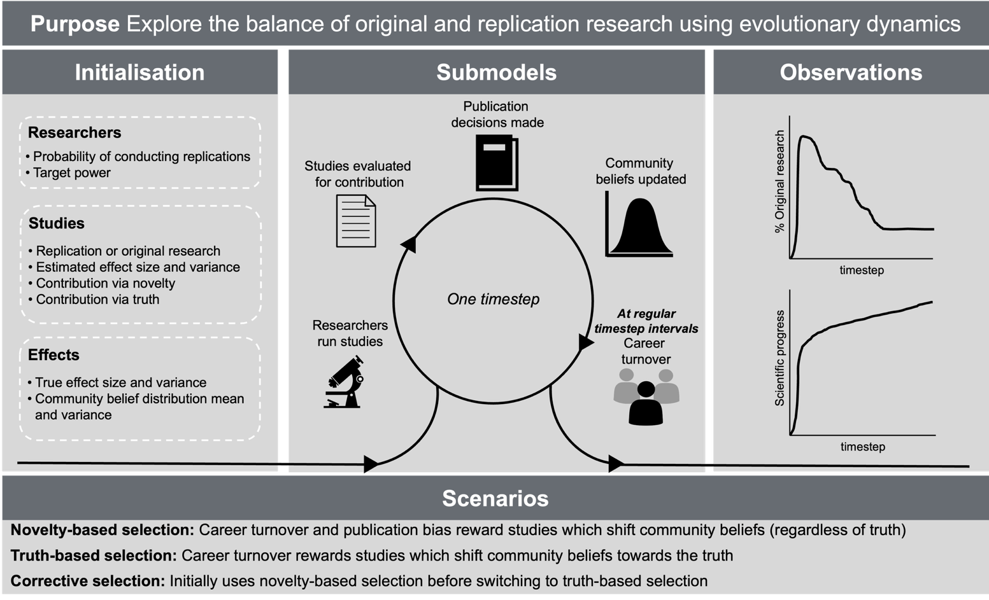*Visual ODD of the Science Under Selection Agent-Based Model*

## 4. Design concepts

***Basic principles.*** The model is grounded in evolutionary theory applied to academic progress. The design reflects the principle that individual traits (research tendencies) can spread or decline via selection pressures imposed by institutional structures. Specifically, this model explores the balance of original and replication research and uses evolutionary dynamics to reveal ideal conditions for scientific progress.

***Emergence.*** System-level outcomes such as the balance between original and replication research and the accuracy of community beliefs emerge from the interaction of researcher traits, studies, and selection pressure.

***Adaptation.*** Agents are not adaptive in the sense of real-time decision-making; instead, replication tendency is modelled as a trait that is subject to selection. Adaptation occurs at the population level through the differential promotion of researchers with varying traits.

***Objectives.*** Agents do not pursue explicit objectives, but their survival/promotion are contingent on how well their outputs align with the active selection condition. Objectives are therefore implicit and externally defined.

***Learning.*** While individual researchers do not learn, the scientific community as a whole learns through Bayesian updating of belief distributions in response to new studies. This process models the accumulation of knowledge at the community level, but does not influence agents’ behaviour.

***Prediction.*** Agents do not form expectations about the future or attempt to anticipate outcomes.

***Sensing.*** Researchers are not assumed to sense their environment or other agents directly. Only when they are choosing an Effect ID to conduct an original or replication study, they need to sense which Effect IDs have already been investigated.

***Interaction.*** Researchers interact indirectly through their studies, which update community belief distributions. They also influence incoming researchers by transmitting their research practices.

***Stochasticity.*** When researcher agents produce studies, their results are generated from samples of the True effect mean, which introduces random variability around the truth. This stochasticity is essential, as it represents the uncertainty inherent in empirical research and underlies the need for replication to distinguish reliable findings from noise.

***Collectives.*** Researchers do not form explicit groups or networks.

***Observation.*** We observe the distribution of replication tendencies among researchers and the accuracy of community beliefs. These are recorded at each timestep.

## 5. Initialization

At the start of each simulation, researchers, effects, and selection condition, are initialized. All researcher state variables are set, effects are given underlying truths and priors, and the selection condition is specified. We distinguish between parameters that remain fixed across all simulations and parameters that will be systematically varied.

**Fixed parameters**

***Simulation***

* Each simulation starts at timestep = 0 and will be run for approximately 100 timesteps. This may need to be adjusted to ensure observable outcomes.
* The number of simulations will be established through pilot testing to achieve a suitably low Monte Carlo error.

***Researchers***

* Initial researchers are populated (N = number of available career positions).
* Each researcher is assigned an initial replication probability and target power drawn from a baseline distribution (e.g., a flat uniform distribution between 0 and 1).

***Career market***

* A fixed number of available positions (approximately N = 10,000).
* Promotions occur at regular intervals after a set number of timesteps.
* A certain percentage of agents miss out on promotion and exit academia.

***Effects***

* The community belief distribution is initialized as an uninformed prior (e.g., normal distribution with large variance, centred around zero).

**Variable parameters**

***Selection pressure***

* The model will be run under three selection conditions:

1. Novelty-based selection.
2. Truth-based selection.
3. Corrective selection (first half novelty-based, second half truth-based; this condition will run for twice as many timesteps, as both selection models will be fully executed).

***Effect distributions***

* Two scenarios for the prevalence of true effects will be explored, guided by estimates used in previous work (Ioannidis, 2005).

1. Realistic scenario:10% of True effect mean values are non-zero.
2. Generous scenario: 50% of True effect mean values are non-zero.

* True effect mean values are assigned non-zero values drawn from an empirically-supported defined distribution, while null effects are set to zero.

## 6. Input data

The model does not use any input data to represent time-varying processes.

## 7. Submodels

***Researchers run studies.***  Each timestep, agents continue their existing study or start conducting a new study. Each agent runs only one single-authored study at a time. There is no “idling” without research activity. An original study involves randomly selecting a previously unpublished Effect ID, while a replication involves randomly selecting an Effect ID that has already been published. Original studies take longer to produce than replication studies. The necessary sample size is decided using the author agent’s Target power, assuming either the mean published effect size (for original studies) or the original study’s effect size (for replications). Studies with larger sample sizes take longer to produce. Study outcomes are generated by drawing a sample effect size from a distribution centred on the true effect value, with variability introduced through sampling error.

***Research is evaluated for contribution.*** The potential contribution of each completed study is calculated here, but study estimates are only incorporated into community beliefs if the study is published. A study’s potential Novelty contribution is operationalized as the KL-divergence between the posterior and prior belief distributions (if it were to be published), representing how novel the conclusions are, regardless of truth. A study’s potential Truth contribution is operationalized as (1) the KL-divergence between the Effect ID’s true effect distribution and the prior belief distribution, minus (2) the KL-divergence between the Effect ID’s true effect distribution and the posterior belief distribution (if it were to be published), representing how much the study shifts the community belief towards (or away from) the truth. These measures later serve as fitness indicators for researchers.

***Publication decisions are made.*** In the truth-based selection condition, all studies are published. In the novelty-based selection condition, not all produced studies are published. Publication bias operates on two criteria: the potential Novelty contribution of the study and the statistical significance of the finding (*p*-value). Publication bias follows two axioms: first, given the same level of novelty, significant results are more likely to be published than non-significant ones; and second, given the same level of significance, novel findings are more likely to be published than less novel ones. These axioms together generate a consistent outcome hierarchy, ranging from the lowest publication probability for low-novelty, non-significant studies to the highest for high-novelty, significant studies. A study’s probability of publication, shown in Figure 2, follows one of two logistic functions based on novelty and significance.

**Figure 2**

*Publication probability as a function of novelty and significance*

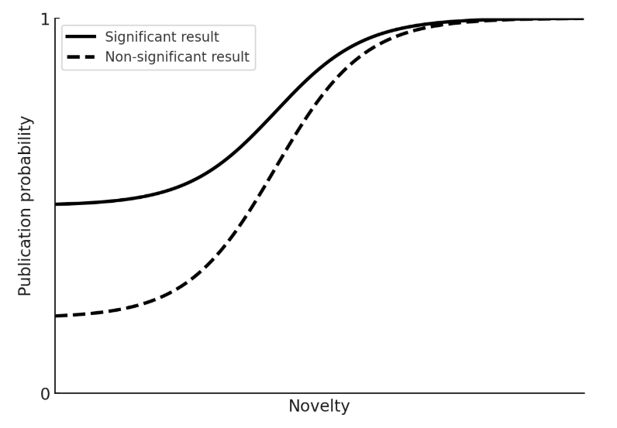

***Community beliefs are updated.*** Once published, study outcomes are used to update the community’s beliefs about the studied effect. Community beliefs are modelled as probability distributions and are updated using Bayesian inference, specifically normal-normal conjugacy, where the prior distribution (Prior mean and Prior variance) is updated with the study’s observed Estimated mean and Estimated standard error to produce a posterior distribution. This posterior replaces the prior as the updated community belief distribution, allowing community knowledge to accumulate across studies.

***Career turnover.*** Career transitions occur in a career turnover phase at regular intervals after a set number of timesteps. Researchers are ranked according to their accumulated fitness, based on either their total number of published studies (novelty-based selection) or the cumulative truth contribution of their published studies (truth-based selection). A fixed proportion of the lowest-ranked agents exit academia, while the remaining agents are promoted (i.e., allowed to continue). If ties occur, promotions among tied candidates are decided randomly. Vacant positions are then filled by new entrants, who inherit their replication probability and target power from existing scores within the active academic population with some additional random variation to capture imperfect transmission, individual variability, and innovation.

References

Grimm, V., Railsback, S. F., Vincenot, C. E., Berger, U., Gallagher, C., DeAngelis, D. L., Edmonds, B., Ge, J., Giske, J., Groeneveld, J., Johnston, A. S. A., Milles, A., Nabe-Nielsen, J., Polhill, J. G., Radchuk, V., Rohwäder, M.-S., Stillman, R. A., Thiele, J. C., & Ayllón, D. (2020). The ODD Protocol for Describing Agent-Based and Other Simulation Models: A Second Update to Improve Clarity, Replication, and Structural Realism. *Journal of Artificial Societies and Social Simulation*, *23*(2), 7. https://doi.org/10.18564/jasss.4259

Ioannidis, J. P. A. (2005). Why Most Published Research Findings Are False. *PLoS Medicine*, *2*(8), e124. https://doi.org/10.1371/journal.pmed.0020124

Smaldino, P. E., & McElreath, R. (2016). The natural selection of bad science. *Royal Society Open Science*, *3*(9), 160384. https://doi.org/10.1098/rsos.160384